**Experiment No 2**

**Aim: Study of different types of Network cables.**

**Different type of cables used in networking are:**

1. **Unshielded Twisted Pair (UTP) Cable**
2. **Shielded Twisted Pair (STP) Cable**
3. **Coaxial Cable**
4. **Fiber Optic Cable**

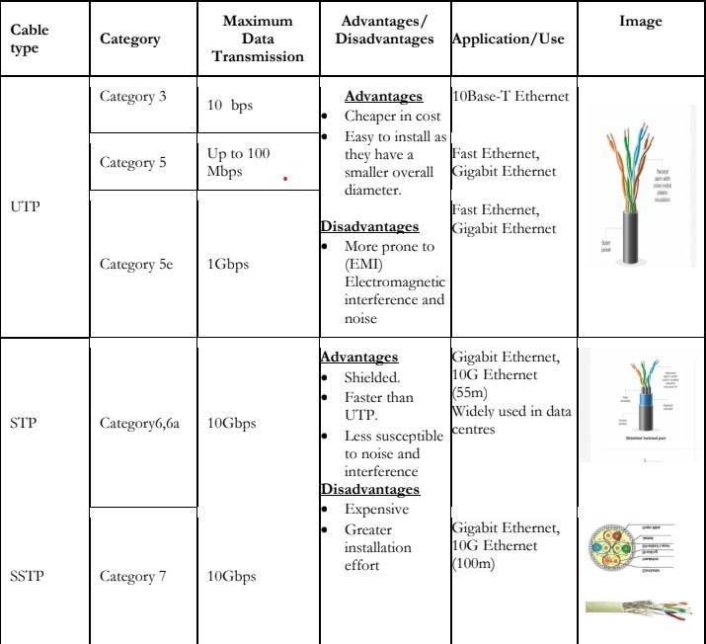

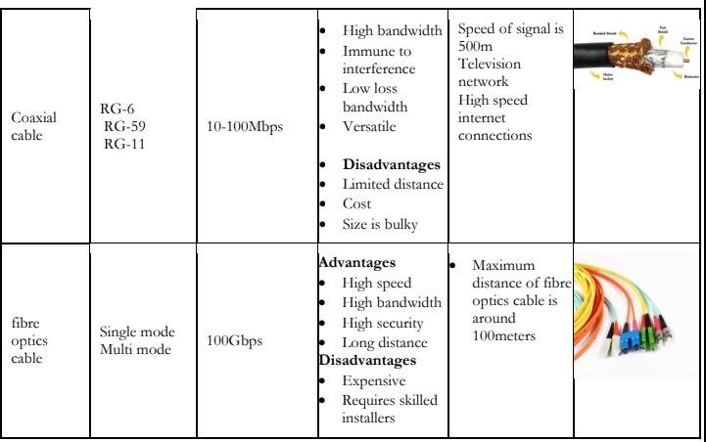

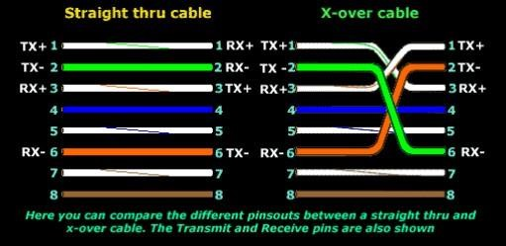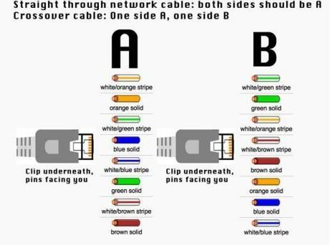

**Step 1:** To start construction of the device, begin by threading shields onto thecable.

crimping tool has a round area to complete this task.

**Step 3**: After, you will need to untangle the wires; there should be four “twisted pairs.”

Referencing back to the sheet, arrange them from top to bottom. One end shouldbe in

arrangement A and the other in B.

**Step 4**: Once the order is correct, bunch them together in a line, and if there areany that

stick out farther than others, snip them back to create an even level. The difficultaspect

is placing these into the RJ45 plug without messing up the order. To do so, hold theplug

with the clip side facing away from you and have the gold pins facing toward you,as

shown.

**Step 5**: Next, push the cable right in. The notch at the end of the plug needs to bejust

over the cable shielding, and if it isn’t, that means that you stripped off too muchshielding. Simply snip the cables back a little more.

**Step 6**: After the wires are securely sitting inside the plug, insert it into the crimping tool

and push down. It should be shaped correctly, but pushing too hard can crack thefragile plastic plug.

**Step 7:** Lastly, repeat for the other end using diagram B (to make a crossover cables)/

using diagram A (to make a straight through cable)

To test it, plug it in and attempt to connect two devices directly.



**Result :**

**The Study of different types of Network cables has been successfully executed.**